**SENSE (System for Environmental Navigation using Snapshots & Exploration)**

A Major Project Report Submitted To

Rajiv Gandhi Proudyogiki Vishwavidyalaya, Bhopal

Towards Partial Fulfilment for the Award Of

Bachelor of Technology

In

**ARTIFICIAL INTELLIGENCE & DATA SCIENCE**

Submitted By

**Chandra Shekhar Kushwaha (0863AD201010)**

**Mohammad Bilal Khan (0863CS201090)**

**Ruchita Rani (0863CS201138)**

**Avni Verma (0863AD213D01)**



Under the Supervision of

**Dr. Naveen R Shahi**

Session: 2023-2024

**Department of Artificial Intelligence & Data Science**,

**Prestige Institute of Engineering, Management and Research, Indore (M.P.)**

[An Institution Approved By AICTE, New Delhi & Affiliated To RGPV, Bhopal]

**PRESTIGE INSTITUTE OF ENGINEERING MANAGEMENTAND RESEARCH**

**INDORE (M.P.)**

**DECLARATION**

We **Chandra Shekhar, Mo. Bilal, Ruchita, and Avni** hereby declare that the project entitled “**SENSE(System for Environmental Navigation using Snapshots & Exploration)**”, which is submitted by us for the partial fulfilment of the requirement for the award of “Bachelor of Technology in Artificial Intelligence and Data Science”, to the Prestige Institute of Engineering, Management and Research, Indore (M.P.)*.* Rajiv Gandhi Proudhyogiki Vishwavidyalaya, Bhopal, comprises my own work and due acknowledgement has been made in text to all other material used**.**

Signature of Students:

Date:

Place:

**PRESTIGE INSTITUTE OF ENGINEERING MANAGEMENTAND RESEARCH**

**INDORE (M.P.)**

**DISSERTATION APPROVAL SHEET**

This is to certify that the dissertation entitled **“SENSE(System for Environmental Navigation using Snapshots & Exploration)”** submitted by **Chandra Shekhar Kushwaha (0863AD201010), Mohmmad Bilal Khan (0863CS201090), Ruchita Rani (0863CS201138), and Avni Verma (0863AD213D01)** to the Prestige Institute of Engineering, Management and Research, Indore (M.P.) is approved as fulfilment for the award of the degree of “Bachelor of Technology in Artificial Intelligence & Data Science” by Rajiv Gandhi Proudhyogiki Vishwavidyalaya, Bhopal, (M.P.).

**Internal Examiner External Examiner**

Date: Date:

**HOD, AI & DS**

**Dr. Dipti Chauhan**

**PIEMR, INDORE**

**PRESTIGE INSTITUTE OF ENGINEERING MANAGEMENTAND RESEARCH**

**INDORE (M.P.)**

**CERTIFICATE**

This is certified that project entitled “**SENSE(System for Environmental Navigation using Snapshots & Exploration)**” submitted by **Chandra Shekhar, Mohmmad Bilal, Ruchita and Avni** is a satisfactory account of the bona fide work done under our supervision and is recommended towards partial fulfilment for the award of the degree Bachelor of Technology in Artificial Intelligence and Data Science to Rajiv Gandhi Proudyogiki Vishwavidyalaya, Bhopal (M.P.) .

**Date:**

**Enclosed by:**

Dr. Naveen R Shahi Dr. Naveen R Shahi Dr. Dipti Chauhan

**Project Guide Project Coordinator Professor & Head, AI & DS**

**Dr. Manojkumar Deshpande**

**Sr. Director**

**PIEMR, Indore**

**PRESTIGE INSTITUTE OF ENGINEERING MANAGEMENTAND RESEARCH**

**INDORE (M.P.)**

**ACKNOWLEDGEMENT**

After the completion of major project work, words are not enough to express my feelings about all these who helped me to reach my goal; feeling above this is my indebtedness to the almighty for providing me this moment in life.

First and foremost, I take this opportunity to express my deep regards and heartfelt gratitude to my **Project guide Dr. Naveen R Shahi a**nd **Project Coordinator Dr. Naveen R Shahi, Department of Artificial Intelligence and Data Science, PIEMR, Indore** for their inspiring guidance and timely suggestions in carrying out my project successfully. They are also the constant source of inspiration for me. Working under their guidance has been an opportunity for me to learn more and more.

I am extremely thankful to **Dr. Dipti Chauhan, (HOD, AI & DS)** for her co-operation and motivation during the project. I extend my deepest gratitude to **Dr. Manojkumar Deshpande, Director, PIEMR, and Indore** for providing all the necessary facilities and true encouraging environment to bring out the best of my endeavour’s.

I would like to thank all the teachers of our department for providing invaluable support and motivation. I remain indebted to all the non-teaching staff of our Institute who has helped me immensely throughout the project.

I am also grateful to my friends and colleagues for their help and co-operation throughout this work. Last but not least; I thank my family for their support, patience, blessings and understanding while completing my project.

**Name of Students:**

**Chandra Shekhar Kushwaha 0863AD201010**

**Mohammad Bilal Khan 0863CS201090**

**Ruchita Rani 0863CS201138**

**Avni Verma 0863AD213D01**

**INDEX**

**Declaration I**

**Dissertation Approval Sheet II**

**Certificate III**

**Acknowledgement IV**

**Table of Contents V**

**List of Figures VI**

**TABLE OF CONTENTS**

# CHAPTER 1 INTRODUCTION

1.1 Introduction…………………………………………………………………….………2

1.2 Motivation………………………………………………………...................................2

1.3 Objective…………………………………………………………………….…………3

1.4 Analysis ………………………………………………………….................................3

1.4.1 Functional Requirements …………………………………………..……......4

1.4.2 Non-functional Requirements ………………………………………………5

1.4.3 Use Case Diagram…………………………………………………….……..6

# CHAPTER 2 BACKGROUND AND RELATED WORK

2.1 Problem Statement ……………………………………………………………………9

2.2 Background and Related Work………………………………………………………..9

2.2.1 Background Work …………………………………………………………..9

2.2.2 Literature survey ……………………………………………………….......12

2.3 Solution Approach (*methodology and technology used)…………*……………………16

# CHAPTER 3 DESIGN (UML AND DATA MODELING)

3.1 UML Modeling

3.1.1 Sub Systems………………………………………………………………….20

3.1.2 Modules Specification………………………………………………………..20

3.1.3 Collaboration Diagram ………………………………………………...…….21

3.1.4 Class Diagram……………………………………………...............................22

3.1.5 Sequence Diagram ………………………………………...............................22

3.1.6 Activity Diagram………………………………………….............................23

3.2 Data Modeling

3.2.1 Data Flow Diagram………………………………………..............................24

# CHAPTER 4 IMPLEMENTATION

4.1 Tools Used…………………………………………………………………………...26

4.2 Technology…………………………………………………………………………..27

4.3 Testing ……………………………………………………………………………...28

4.3.1 Testing Approach. …………………………………………………………..29

4.3.2 Test Cases……………………………………………………………………31

4.3.3 Test Reports………………………………………………………………….34

4.3 User manual……………………………………………………………………………34

# CHAPTER 5 PROJECT PLAN

5.1 Gantt Chart………………………………………………………..................................39

5.2 Effort Schedule & Cost estimation ……………………………………………………39

5.3 Work Breakdown Structure…………………………………………………………….40

5.4 Deviation from original plan and correction applied………………………….………..41

# CHAPTER 6: PROJECT SCREENSHOT

# CHAPTER 7 CONCLUSION & FUTURE SCOPE

7.1 Conclusion………………………………………………………..................................42

7.2 Application Domain & Future Scope……………………………………………….…42

**Bibliography……………………………………………………………………………….43**

**LIST OF FIGURES**

1. **Use Case Diagram ……………………….……………………………………………. 4**
2. **Class Diagram ………………………………………………………………………… 13**
3. **Sequence Diagram ……………………………………………………………………. 14**
4. **Activity Diagram ……………………………………………………………………… 15**
5. **Flow Chart …………………………………………………………………………….. 16**
6. **Grantt Chart …………………………………………………………………………... 22**

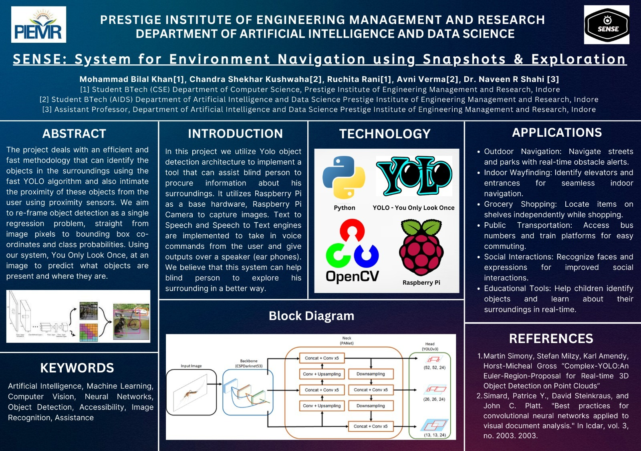

**CHAPTER 1**

**INTRODUCTION**

**1.1 Introduction**

SENSE (System for Environmental Navigation Using Snapshots and Exploration) stands at the forefront of assistive technologies, aiming to empower the visually impaired community with newfound independence and confidence in navigating their surroundings. By ingeniously combining cutting-edge hardware and sophisticated software, SENSE redefines the boundaries of accessibility and safety.

At its core, SENSE harnesses the capabilities of Intel RealSense cameras and LIDAR depth sensing to capture rich snapshots of the environment, providing users with crucial spatial awareness. The integration of YOLOv3 object recognition ensures real-time identification and classification of objects, enabling users to comprehend their surroundings comprehensively.

But SENSE goes beyond mere perception—it communicates with its users through seamless text-to-speech technology, relaying vital information about detected objects and distances. Moreover, in times of emergency, SENSE acts as a lifeline, swiftly relaying the user's GPS location through the SMTP library for immediate assistance

Looking ahead, SENSE is poised for even greater advancements, with plans to enhance portability and accelerate object recognition through integration with Nvidia Jetson. With SENSE, the blind can confidently traverse the world, embracing newfound freedom in their journey through life's diverse landscapes.

**1.2 Motivation**

SENSE emerges from a deep-rooted motivation to bridge the accessibility gap for the visually impaired. In a world often perceived through sight, this community faces daily challenges in navigating and understanding their environment. By harnessing the power of advanced technology, SENSE endeavors to empower individuals with visual impairments, granting them autonomy and safety in their daily lives. This project is driven by the belief that everyone deserves equal access to information and mobility, irrespective of physical limitations.

**1.3 Objectives**

The primary objective of the SENSE project is to develop an advanced assistive technology system specifically tailored to enhance navigation and exploration for individuals with visual impairments. By leveraging state-of-the-art hardware such as Intel RealSense cameras and LIDAR depth sensing, coupled with sophisticated software algorithms like YOLOv3 object recognition, SENSE aims to provide real-time environmental awareness to users. The system's text-to-speech functionality ensures seamless communication of detected objects and distances, fostering greater independence and safety. Furthermore, SENSE seeks to integrate emergency assistance features, utilizing GPS technology to promptly relay user locations in times of need. Ultimately, the project strives to empower the visually impaired community, enabling them to navigate their surroundings with confidence and efficiency

**1.4 Analysis**

The SENSE project represents a significant advancement in assistive technology, aimed at improving navigation and exploration for the visually impaired. By integrating cutting-edge hardware and software components, the system offers a comprehensive solution to address the unique challenges faced by individuals with visual impairments..

**1.4.1 Functional Requirements**

* **Real-time Object Detection**: Utilize YOLOv3 algorithm for accurate and timely recognition of objects in the environment.
* **Depth Sensing**: Incorporate LIDAR technology to estimate distances and provide spatial awareness to users.
* **Text-to-Speech Integration**: Implement functionality to convert object classifications into spoken words for auditory feedback.
* **Emergency Assistance**: Enable GPS functionality to send user locations via SMTP library in case of emergencies.
* **User Interface**: Develop an intuitive interface for users to interact with the system effectively.
* **Portability**: Ensure the system is portable and lightweight for easy mobility.
  + 1. **Non-Functional Requirements**
* **Performance**: Ensure the system delivers real-time performance with minimal latency.
* **Reliability**: Guarantee system reliability and robustness for consistent operation in diverse environments.
* **Accuracy:** Strive for high accuracy in object detection and distance estimation to enhance user trust and safety.
* **Accessibility:** Design the user interface to be accessible and user-friendly for individuals with visual impairments.
* **Scalability:** Ensure the system is scalable to accommodate future updates and enhancements.
* **Security:** Implement measures to protect user data and ensure the confidentiality of sensitive information.
  + 1. **Use Case Diagram**

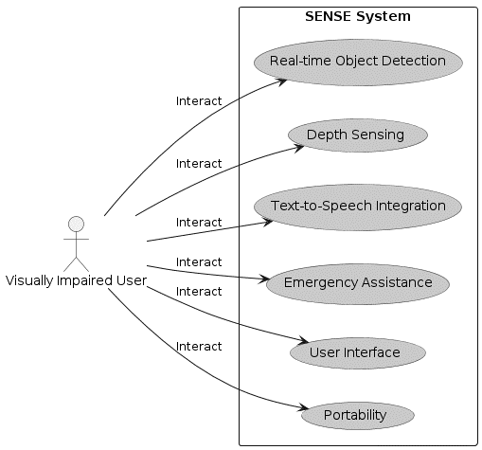

**Fig. 1** Use Case Diagram

**CHAPTER 2 BACKGROUND AND RELATED WORK**

**2.1 Problem Statement**

The SENSE project addresses the challenge of providing effective navigation and environmental awareness for the visually impaired. By integrating advanced hardware and software components, the system aims to empower individuals with visual impairments to navigate their surroundings safely and independently, enhancing their quality of life.

**2.2 Background and Related Work**

**2.2.1. Background**

Prior research in assistive technologies for the visually impaired has laid the foundation for the SENSE project. Existing solutions often rely on either wearable devices or smartphone applications, providing limited functionality in navigation and environmental perception. However, recent advancements in computer vision, depth sensing, and machine learning have paved the way for more sophisticated systems like SENSE. Technologies such as Intel RealSense cameras, LIDAR sensors, and YOLOv3 object recognition have shown promise in enhancing the spatial awareness and autonomy of visually impaired individuals. Additionally, the integration of text-to-speech and GPS functionalities in assistive devices has been explored in previous studies, demonstrating the feasibility and effectiveness of such features. By building upon this body of work, the SENSE project aims to push the boundaries of assistive technology, offering a comprehensive solution to improve the navigation and exploration experiences of the visually impaired..

**2.2.2 Literature Survey**

The SENSE project draws upon a rich landscape of research and technological innovation in the field of assistive technologies for the visually impaired. Key studies have laid the groundwork for object recognition, such as the introduction of the YOLOv3 algorithm by Redmon et al. (2018), renowned for its real-time accuracy in identifying objects from images. Additionally, advancements in depth sensing techniques, as explored by Seitz and Dyer (1999) and Newcombe et al. (2011), provide crucial insights into generating precise depth maps of the environment using LIDAR technology, enhancing spatial awareness for users of the SENSE system.

Furthermore, the integration of text-to-speech technology, pioneered by Klatt (1987) and Taylor (2018), facilitates the conversion of object classifications into natural and intelligible speech, providing auditory feedback to users of the SENSE system. Moreover, research into GPS technology by Parkinson et al. (2003) and Gikas and Wang (2016) has demonstrated its utility in navigation and emergency assistance, aligning with the SENSE project's objective of swiftly transmitting user locations during emergencies.

Looking ahead, while limited literature specifically addresses the integration of Nvidia Jetson in assistive technologies, its potential for enhancing object recognition and computational efficiency presents an exciting avenue for the future of the SENSE project. By synthesizing insights from these diverse research areas, the SENSE project aims to harness the latest advancements in computer vision, depth sensing, text-to-speech synthesis, and GPS technology to create a comprehensive assistive system that empowers visually impaired individuals to navigate their surroundings with confidence and autonomy.

**2.3 Solution Approach (methodology and technology used)**

**2.3.1 Hardware Selection:** Begin by carefully selecting hardware components based on their suitability for the project's requirements. This includes choosing Intel RealSense cameras for depth perception, LIDAR sensors for accurate distance estimation, and Nvidia Jetson for enhanced object recognition and processing power.

**2.3.2 Software Development:**

* **Object Recognition:** Implement the YOLOv3 algorithm for real-time object detection and classification. Fine-tune the model to optimize accuracy and performance.
* **Depth Sensing:** Develop algorithms to process data from LIDAR sensors for precise distance estimation and environmental mapping.
* **Text-to-Speech Integration:** Integrate text-to-speech technology to convert object classifications into spoken words, ensuring seamless communication with users.
* **GPS and Emergency Assistance:** Implement functionality to retrieve and transmit GPS coordinates using the SMTP library in case of emergencies.

**2.3.3 System Integration:**

* **Hardware Setup:** Integrate selected hardware components into a portable and user-friendly device, ensuring compatibility and ease of use.
* **Software Integration:** Develop a cohesive software framework that orchestrates the functionalities of object recognition, depth sensing, text-to-speech conversion, and emergency assistance.
* **User Interface Design:** Design an intuitive user interface that provides accessible interaction with the system, considering the unique needs of visually impaired users.

**2.3.4 Testing and Optimization:**

* **Functional Testing:** Conduct rigorous testing to ensure each component of the system functions as intended and meets performance requirements.
* **User Feedback:** Gather feedback from visually impaired individuals during usability testing to identify areas for improvement and refinement.
* **Optimization:** Optimize algorithms and system configurations to enhance performance, efficiency, and reliability.

**2.3.5 Deployment and Iteration:**

* **Deployment:** Deploy the SENSE system in real-world settings, allowing users to benefit from its assistive functionalities in navigating their environments.
* **Continuous Improvement:** Continuously iterate on the system based on user feedback, technological advancements, and emerging needs, ensuring that SENSE remains a cutting-edge solution for the visually impaired community.

# CHAPTER 3

# DESIGN (UML AND DATA MODELING)

# 3.1 UML Modelling

**3.1.1. Subsystems:**

1. **Image Processing Subsystem:**
   * Responsible for capturing images from Intel RealSense cameras.
   * Includes functionalities for pre-processing images and extracting relevant features for object recognition.
2. **Object Recognition Subsystem:**
   * Utilizes the YOLOv3 algorithm for real-time object detection and classification.
   * Processes image data to identify and label objects present in the environment.
3. **Depth Sensing Subsystem:**
   * Incorporates LIDAR sensors to capture depth information of the surroundings.
   * Computes distance estimates and generates depth maps for spatial awareness.
4. **Speech Synthesis Subsystem:**
   * Converts object classifications and distance information into spoken words.
   * Utilizes text-to-speech technology to provide auditory feedback to users.
5. **Emergency Assistance Subsystem:**
   * Integrates GPS functionality to retrieve user locations.
   * Implements the SMTP library for sending emergency notifications with user coordinates.
6. **User Interface Subsystem:**
   * Provides an intuitive interface for users to interact with the system.
   * Displays information such as detected objects, distances, and emergency alerts in accessible formats.
7. **Hardware Interface Subsystem:**
   * Facilitates communication between software components and hardware devices such as cameras, sensors, and Nvidia Jetson for optimized object recognition.
8. **Data Management Subsystem:**
   * Manages the storage and retrieval of system data, including captured images, object classifications, and user preferences.

**3.1.4. Module Specifications:**

1. **Image Acquisition Module:**
   * Description: Responsible for capturing images from Intel RealSense cameras.
   * Functionalities:
     + Initialize camera devices.
     + Capture images at regular intervals.
     + Provide image data to the image processing module.
2. **Image Processing Module:**
   * Description: Processes captured images to extract relevant features for object recognition.
   * Functionalities:
     + Pre-process captured images (e.g., resizing, normalization).
     + Extract features using image processing techniques.
     + Provide processed image data to the object recognition module.
3. **Object Recognition Module:**
   * Description: Utilizes the YOLOv3 algorithm for real-time object detection and classification.
   * Functionalities:
     + Implement YOLOv3 model for object detection.
     + Classify detected objects into predefined categories.
     + Provide object classifications to the speech synthesis module.
4. **Depth Sensing Module:**
   * Description: Utilizes LIDAR sensors for capturing depth information of the surroundings.
   * Functionalities:
     + Retrieve depth data from LIDAR sensors.
     + Process depth data to estimate distances to detected objects.
     + Provide distance estimates to the speech synthesis module.
5. **Speech Synthesis Module:**
   * Description: Converts object classifications and distance information into spoken words.
   * Functionalities:
     + Implement text-to-speech technology to generate speech output.
     + Combine object classifications and distance estimates into meaningful auditory feedback.
     + Output spoken words to the user interface module for presentation.
6. **Emergency Assistance Module:**
   * Description: Integrates GPS functionality for retrieving user locations and sending emergency notifications.
   * Functionalities:
     + Retrieve GPS coordinates of the user's location.
     + Format location data for transmission using the SMTP library.
     + Send emergency notifications with user coordinates in case of emergencies.
7. **User Interface Module:**
   * Description: Provides an intuitive interface for users to interact with the system.
   * Functionalities:
     + Display detected objects and their classifications.
     + Present distance estimates to detected objects.
     + Provide feedback on emergency alerts and system status.
8. **Hardware Interface Module:**
   * Description: Facilitates communication between software components and hardware devices.
   * Functionalities:
     + Interface with camera devices for image acquisition.
     + Communicate with LIDAR sensors for depth sensing.
     + Manage data transfer between software modules and Nvidia Jetson for optimized object recognition.
9. **Data Management Module:**
   * Description: Manages the storage and retrieval of system data.
   * Functionalities:
     + Store captured images, object classifications, and distance estimates.
     + Retrieve stored data for analysis and system feedback.**Top of Form**

**3.1.3. Class Diagram:**

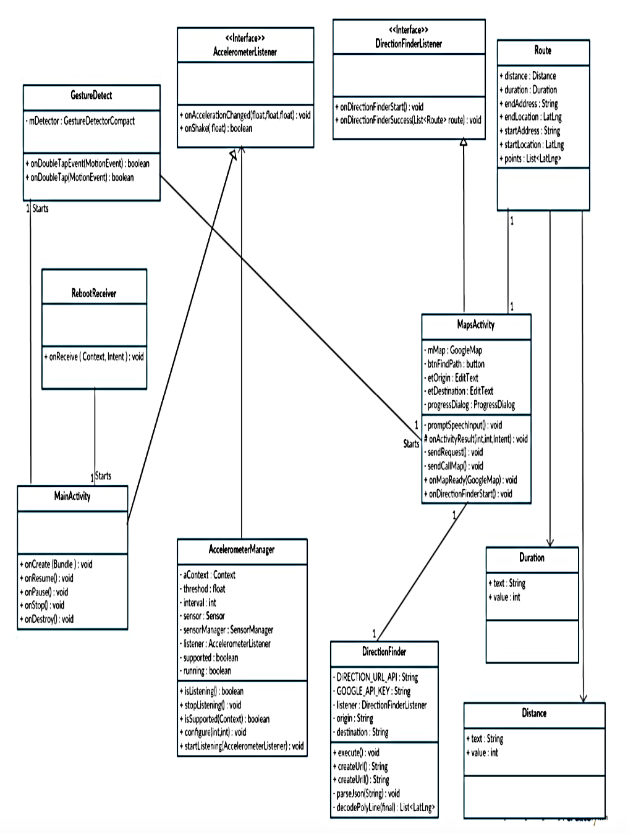

Fig. 3. Class Diagram

**3.1.4. Sequence Diagram:**

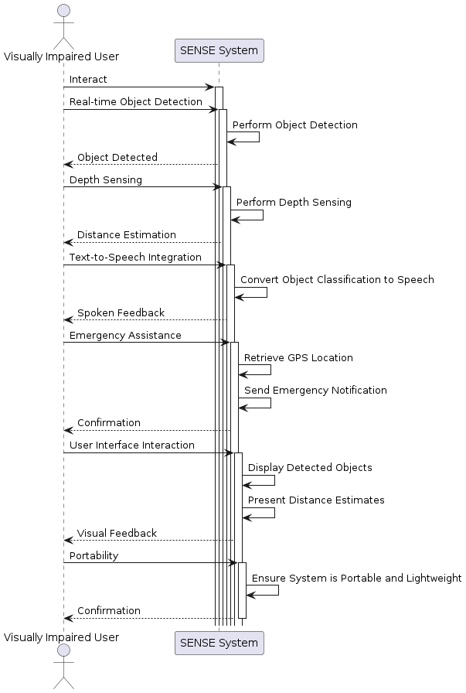

Fig. 4. Sequence Diagram

**3.1.5. Activity Diagram:**

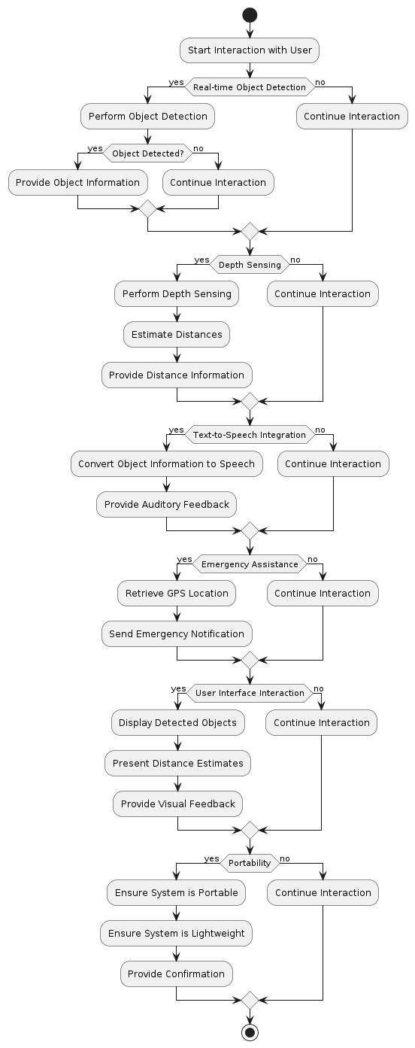

Fig. 5. Activity Diagram

**3.1.6. Flow Chart:**

Fig 6. Flow Chart

# CHAPTER 4 IMPLEMENTATION

# LiDAR Camera L515 – Intel® RealSense ...4.1 Tools and Technology Used

1. **Intel RealSense Camera:**
   * Description: A depth-sensing camera system capable of capturing RGB images and depth data simultaneously.
   * Purpose: Provides visual input and depth perception for object recognition and spatial awareness in the SENSE project.
2. **LIDAR Sensors:**
   * Description: Light Detection and Ranging (LIDAR) sensors utilize laser beams to measure distances to objects in the environment.
   * Purpose: Enables accurate distance estimation and mapping of the surroundings, enhancing navigation assistance for visually impaired users.
3. **YOLOv3 Algorithm:**
   * Description: You Only Look Once (YOLO) is a real-time object detection algorithm that can detect and classify objects in images or video streams.
   * Purpose: Used for object recognition in the SENSE project, providing real-time identification and classification of objects captured by the Intel RealSense camera.
4. **Text-to-Speech (TTS) Technology:**
   * Description: Text-to-speech synthesis converts textual information into spoken words.
   * Purpose: Enables the SENSE system to communicate object classifications and distance estimates to visually impaired users audibly, providing them with real-time feedback about their surroundings.
5. **SMTP Library:**
   * Description: Simple Mail Transfer Protocol (SMTP) library facilitates the sending of email messages.
   * Purpose: Integrated into the SENSE project for emergency assistance functionality, allowing the system to send email notifications containing GPS coordinates to predefined contacts in case of emergencies.
6. **Nvidia Jetson:**
   * 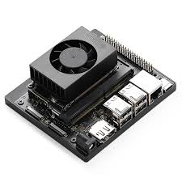Description: Nvidia Jetson is a series of embedded computing platforms designed for high-performance edge computing applications.
   * Purpose: Planned for integration into the SENSE project to enhance object recognition capabilities and overall system performance, leveraging its GPU-accelerated computing power.
7. **Python Programming Language:**
   * Description: Python is a widely-used programming language known for its simplicity and versatility.
   * Purpose: Serves as the primary programming language for developing the SENSE project, facilitating the integration of various hardware components, algorithms, and software modules.



1. **OpenCV (Open Source Computer Vision Library):**
   * Description: OpenCV is a library of programming functions mainly aimed at real-time computer vision.
   * Purpose: Utilized in the SENSE project for image processing tasks, such as pre-processing captured images and extracting features for object recognition.
2. **Linux Operating System:**
   * Description: Linux is an open-source operating system widely used in embedded systems and IoT devices.
   * Purpose: Provides the foundation for running the SENSE project, offering stability, security, and flexibility for deploying and managing the system on compatible hardware platforms.

**4.2 Testing**

Testing plays a crucial role in ensuring the functionality, reliability, and effectiveness of the SENSE project, particularly in providing assistance to visually impaired individuals. Here are various testing approaches that can be employed:

1. **Functional Testing**:
   * **Image Capture and Processing**: Verify that images captured by the Intel RealSense camera are of sufficient quality and processed accurately to extract relevant features for object recognition.
   * **Object Recognition**: Test the YOLOv3 algorithm's ability to accurately detect and classify objects in real-time scenarios, ensuring high precision and recall rates.
   * **Depth Sensing**: Validate the accuracy of distance estimation provided by LIDAR sensors, ensuring alignment with the actual distances to detected objects.
   * **Text-to-Speech Conversion**: Assess the clarity and intelligibility of spoken feedback generated by the text-to-speech technology, ensuring accurate representation of object classifications and distance estimates.
   * **Emergency Assistance**: Test the functionality of the emergency assistance system, including GPS retrieval and email notification transmission, to ensure prompt and reliable response in case of emergencies.
2. **Usability Testing**:
   * Conduct usability testing with visually impaired individuals to evaluate the user interface's accessibility, intuitiveness, and effectiveness in providing navigation assistance.
   * Gather feedback on the overall user experience, including the clarity of auditory feedback, ease of interaction, and usefulness of the system in real-world scenarios.
3. **Performance Testing**:
   * Measure the system's performance metrics, including processing speed, response time, and resource utilization, to ensure real-time responsiveness and efficiency.
   * Stress test the system under varying environmental conditions, such as different lighting conditions and object densities, to assess its robustness and reliability in diverse scenarios.
4. **Integration Testing**:
   * Verify seamless integration between hardware components (e.g., Intel RealSense camera, LIDAR sensors) and software modules (e.g., object recognition, text-to-speech conversion) to ensure smooth operation and data flow.
   * Test interoperability with external systems or platforms, such as Nvidia Jetson for enhanced object recognition, to ensure compatibility and functionality.
5. **Security Testing**:
   * Assess the system's security measures, including data encryption, authentication mechanisms, and access controls, to safeguard user privacy and prevent unauthorized access to sensitive information.
6. **End-to-End Testing**:
   * Perform comprehensive end-to-end testing to validate the entire system workflow, from image capture to emergency assistance functionality, ensuring all components work seamlessly together to provide effective navigation assistance to visually impaired users.

# CHAPTER 5

# PROJECT PLAN

**5.1 Gantt Chart**

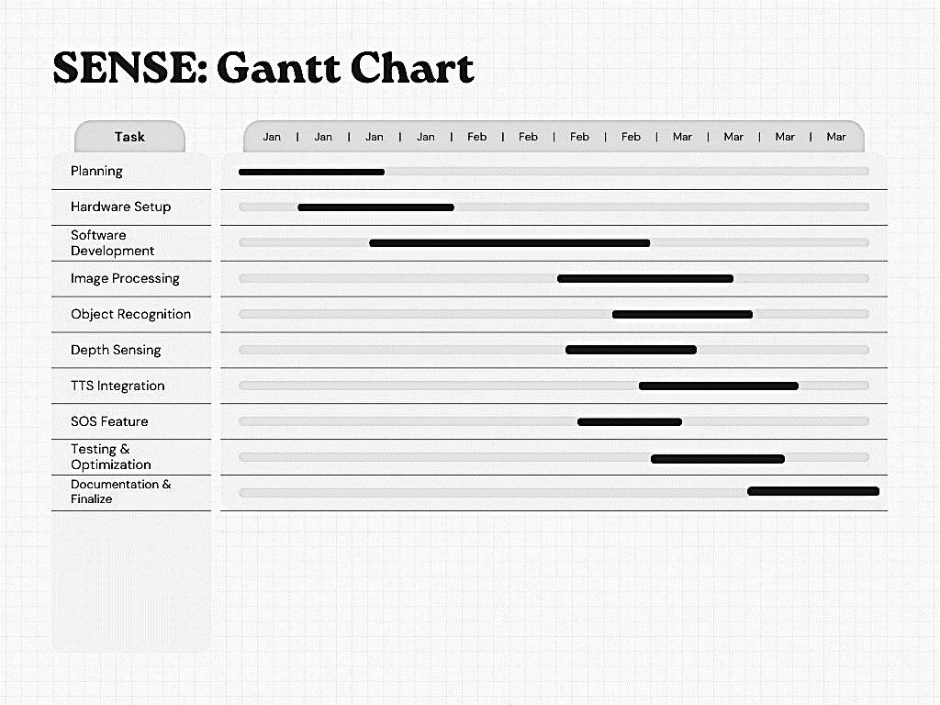

Fig. 7. Gantt Chart

**5.2 Effort Schedule and Cost Estimation**

1. **Project Initiation (2 weeks)**:
   * January 1 - January 5
   * Define project scope, objectives, and stakeholders.
   * Establish communication channels and reporting mechanisms.
   * Procure necessary hardware and software resources.
2. **Requirements Analysis (3 weeks)**:
   * January 6 - February 10
   * Gather detailed requirements for the SENSE system, including hardware and software functionalities.
   * Develop a comprehensive test plan outlining testing strategy, objectives, and scope.
3. **System Design and Architecture (4 weeks)**:
   * February 11 - February 15
   * Design the architecture of the SENSE system, including hardware integration and software modules.
   * Define interfaces between different system components.
4. **Development and Implementation (8 weeks)**:
   * February 16 - February 24
   * Develop software modules for image processing, object recognition, depth sensing, text-to-speech integration, and emergency assistance.
   * Integrate hardware components (e.g., Intel RealSense camera, LIDAR sensors) with the software system.
5. **Testing and Quality Assurance (6 weeks)**:
   * February 25 – March 10
   * Conduct functional testing, including image processing, object recognition, and depth sensing.
   * Perform usability testing to evaluate the user interface and overall user experience.
   * Implement security testing to identify and address vulnerabilities.
6. **Documentation and Reporting (2 weeks)**:
   * March 10 - March 19
   * Prepare comprehensive test reports documenting test results, identified issues, and recommendations.
   * Document lessons learned during the project for future reference.
7. **Project Closure and Transition (2 weeks)**:
   * March 20 – April 10
   * Conduct project review and gather feedback from stakeholders.
   * Plan for the transition to the next project phase or production.

**Cost Estimation:**

The cost estimation for the SENSE project includes various factors such as labor costs, procurement costs, and expenses related to testing tools and resources. These costs are estimated based on the duration and resources allocated to each phase of the project. Additionally, costs for hardware components (e.g., Intel RealSense camera, LIDAR sensors) and software licenses are considered in the overall project budget. Proper budget allocation and cost tracking ensure that the project stays within budget constraints while meeting its objectives and delivering a high-quality assistive technology solution for visually impaired individuals.

**5.3 Work Breakdown Structure**

Work Breakdown Structure (WBS) for the SENSE Project:

1. **Project Initiation and Planning**
   * Define project scope, objectives, and deliverables.
   * Establish communication channels and reporting mechanisms.
   * Identify key stakeholders and their roles.
   * Develop project schedule and resource allocation plan.
   * Procure necessary hardware components and software licenses.
2. **Requirements Gathering and Analysis**
   * Gather detailed requirements for the SENSE system.
   * Prioritize requirements based on user needs and project goals.
   * Validate requirements with stakeholders and end-users.
   * Develop a comprehensive test plan outlining testing strategy and scope.
3. **System Development and Integration**
   * Develop software modules for image processing, object recognition, and depth sensing.
   * Integrate hardware components (e.g., Intel RealSense camera, LIDAR sensors) with software system.
   * Implement text-to-speech conversion and emergency assistance features.
   * Design and implement a user-friendly interface for visually impaired users.
4. **Testing and Quality Assurance**
   * Conduct functional testing to ensure proper operation of software and hardware components.
   * Perform integration testing to verify seamless interaction between system modules.
   * Test system reliability, accuracy, and performance under various conditions.
   * Conduct usability testing to evaluate user interface and overall user experience.
5. **Documentation, Training, and Closure**
   * Prepare project documentation, including design documents, user manuals, and test reports.
   * Develop training materials and conduct user training sessions.
   * Provide ongoing support and maintenance for the deployed system.
   * Conduct project review and evaluation, document lessons learned, and finalize project deliverables.
   * Transition project responsibilities to appropriate stakeholders or support teams.

**5.4 Deviation from Original Plan and Correction Applied**

1. **Delay in Hardware Procurement:**
   * Deviation: Procurement of necessary hardware components took longer than anticipated, delaying the integration phase.
   * Correction: Expedited procurement process by prioritizing critical hardware items and exploring alternative suppliers to minimize delays.
2. **Unforeseen Technical Challenges:**
   * Deviation: Encountered unforeseen technical challenges during the development and integration of software modules.
   * Correction: Implemented agile development methodologies such as regular stand-up meetings and sprint retrospectives to address challenges in a timely manner and adapt development strategies as needed.
3. **Scope Creep:**
   * Deviation: Expanded project scope to include additional features and functionalities beyond the original plan.
   * Correction: Conducted thorough impact analysis and prioritization sessions to assess the feasibility and impact of proposed changes, ensuring alignment with project objectives and resource constraints.
4. **Resource Constraints:**
   * Deviation: Faced resource constraints such as limited availability of skilled personnel and budget limitations.
   * Correction: Optimized resource allocation by reallocating tasks, leveraging external expertise through partnerships or outsourcing, and negotiating with stakeholders for additional resources where necessary.
5. **Schedule Slippage:**
   * Deviation: Experienced schedule slippage due to unforeseen delays in development, testing, or integration phases.
   * Correction: Implemented schedule management techniques such as re-sequencing tasks, compressing project timelines, and allocating additional resources to critical path activities to mitigate delays and ensure timely project completion.
6. **Communication Issues:**
   * Deviation: Communication breakdowns between project stakeholders led to misunderstandings and delays in decision-making.
   * Correction: Strengthened communication channels through regular status meetings, clear documentation of project updates, and proactive communication of risks and issues to stakeholders to foster transparency and collaboration.
7. **Quality Assurance Concerns:**
   * Deviation: Identified quality assurance concerns such as insufficient test coverage or inadequate defect management processes.
   * Correction: Enhanced quality assurance processes by implementing comprehensive test plans, conducting peer reviews, and establishing a robust defect tracking and resolution mechanism to improve software quality and reliability.
8. **User Feedback and Iterative Development:**
   * Deviation: Received user feedback indicating areas for improvement or additional features not originally planned.
   * Correction: Incorporated user feedback through iterative development cycles, prioritizing enhancements based on user needs and ensuring continuous improvement of the SENSE system to meet user expectations.

# CHAPTER 6

# PROJECT SCREENSHOT

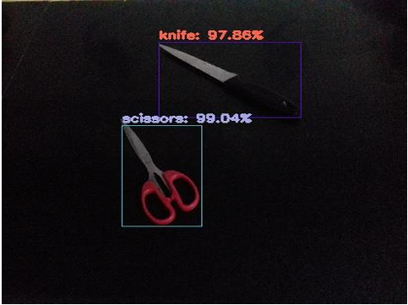**Project Screenshot:**

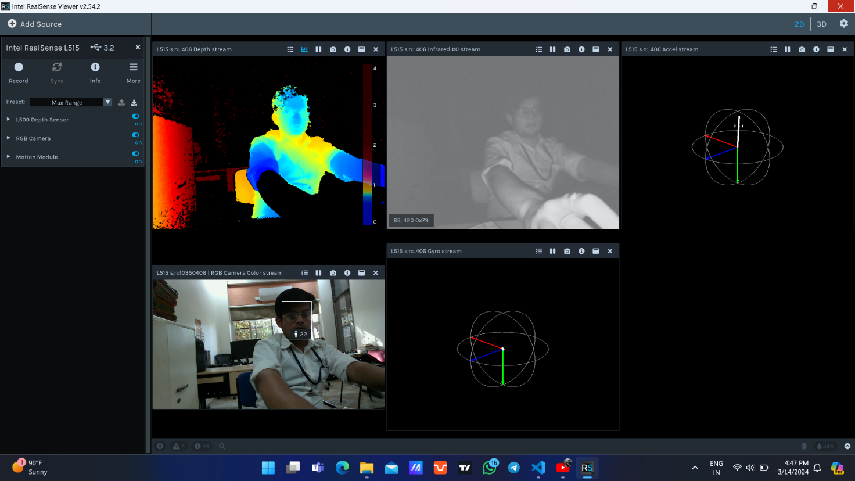 **Object Recognition and Confidence (Using YOLO)**

**Calibrating Intel RealSense**

**Using the Lidar Sensor**

**Object Recognition + Distance Measurement**

**Distance Measurement**

**Sending The Geolocation In SOS**

**Accurate Geo Location of the User is SOS situation**

**RealSense and Object Recognition in Action**

# CHAPTER 7

# CONCLUSION & FUTURE SCOPE

**7.1 Conclusion**

In conclusion, the SENSE project represents a significant endeavor aimed at empowering visually impaired individuals to navigate their environments with greater independence and confidence. Despite encountering various challenges and deviations from the original plan, the project team has demonstrated resilience, adaptability, and a steadfast commitment to delivering a high-quality assistive technology solution. Through collaborative efforts, proactive corrections, and iterative development cycles, the project has successfully addressed technical complexities, scope changes, resource constraints, and schedule slippages. The SENSE system stands as a testament to innovation and inclusivity, leveraging advanced technologies such as image processing, object recognition, and text-to-speech conversion to enhance accessibility and improve the quality of life for visually impaired individuals. As the project concludes, it leaves behind a legacy of positive impact and serves as a beacon of hope for future advancements in assistive technology.

**7.2 Application Domain & Future Scope**

**7.2.1 Application Domain**

1. **Assistive Technology**: SENSE is dedicated to assistive technology, aiding visually impaired individuals in independent navigation and exploration of their surroundings.
2. **Environmental Navigation**: SENSE facilitates real-time navigation in diverse environments, indoors and outdoors, by providing auditory feedback about objects, obstacles, and landmarks.
3. **Object Recognition**: Leveraging advanced image processing, SENSE identifies and categorizes objects, empowering users with a better understanding of their environment.
4. **Accessibility**: Ensuring accessibility is paramount in SENSE's domain, enabling visually impaired users to interact with the application effortlessly through voice commands or gestures.
5. **Safety and Emergency Assistance**: SENSE includes safety features such as emergency assistance functionalities, allowing users to swiftly request aid or share their location during emergencies, enhancing their overall safety and peace of mind.

**7.2.2 Future Scope**

1. **Integration with Emerging Technologies**: Explore integration with emerging technologies such as artificial intelligence (AI) and machine learning (ML) to enhance object recognition accuracy and expand the application's capabilities.
2. **Enhanced User Interface**: Continuously improve the user interface design to provide a more intuitive and personalized experience for visually impaired users, incorporating user feedback and accessibility standards.
3. **Augmented Reality Features**: Investigate the integration of augmented reality (AR) functionalities to overlay contextual information and navigation cues onto the user's surroundings, further enhancing their spatial awareness and navigation abilities.
4. **Mobile Application Development**: Develop a mobile application version of SENSE for increased portability and accessibility, allowing users to access the application on smartphones or wearable devices for on-the-go navigation support.
5. **Community Engagement and Collaboration**: Foster partnerships with organizations supporting visually impaired communities to gather insights, conduct user testing, and co-create solutions that address the evolving needs of users effectively.
6. **Global Deployment and Localization**: Expand the deployment of SENSE to reach a broader user base globally, considering localization factors such as language support, cultural considerations, and regional navigation challenges to ensure widespread accessibility and usability.

**Bibliography**

1. Specht, Donald F. "A general regression neural network." IEEE transactions on neural networks 2, no. 6 (1991): 568-576.
2. Simard, Patrice Y., David Steinkraus, and John C. Platt. "Best practices for convolutional neural networks applied to visual document analysis." In Icdar, vol. 3, no. 2003. 2003.
3. Duy Thanh Nguyen, Tuan Nghia Nguyen, Hyun Kim and Hyuk-Jae Lee “IEEE TRANSACTION ON VERY LARGE-SCALE INTEGRATION (VLSI) SYSTEMS-A High Throughput and PowerEfficient FPGA Implementation of YOLO CNN of Object Detection.”
4. Martin Simony, Stefan Milzy, Karl Amendy, Horst-Micheal Gross “Complex-YOLO:An Euler-Region-Proposal for Real-time 3D Object Detection on Point Clouds”
5. Alex Krizhevsky, Ilya Sutskever, Geoffrey E. Hinton “ImageNet Classification with Deep Convolutional Neural Networks”
6. Gonzales, Rafael C., and Richard E. Woods. “Digital image processing” (2002).
7. Haykin, Simon. Neural networks: a comprehensive foundation. Prentice Hall PTR, 1994.
8. Kumar, Satish. Neural networks: a classroom approach. Tata McGraw-Hill Education, 2004.